Design and Simulation of a Configurable RISC-V Pipeline Processor
1. Introduction
RISC-V is an open-source instruction set architecture (ISA) that is widely used in modern processor design due to its simplicity, modularity, and extensibility. Pipelining is a fundamental technique in processor architecture that improves instruction throughput by overlapping the execution of multiple instructions.
This project focuses on the design, implementation, and simulation of a RISC-V based processor with configurable pipeline depth, supporting both 3-stage and 5-stage pipeline architectures. The processor is implemented in Verilog HDL and simulated using Xilinx Vivado 2018.2.

2. Objective of the Project
The main objectives of this project are:
- To design a RISC-V processor using modular pipeline stages
- To support configurable pipeline depth (3-stage and 5-stage)
- To simulate and verify instruction execution using Vivado
- To analyze pipeline behavior and compare performance

3. Overall Architecture
The processor is divided into the following pipeline stages:
3.1 Instruction Fetch (IF)
- Fetches instruction from instruction memory
- Maintains and updates the Program Counter (PC)
- Instruction memory is initialized using a HEX file
3.2 Instruction Decode (ID)
- Decodes the fetched instruction
- Extracts source and destination register fields
- Reads operands from the register file
3.3 Execute (EX)
- Performs arithmetic and logical operations using the ALU
3.4 Memory Access (MEM)
- Handles load and store instructions
- Interfaces with data memory
3.5 Write Back (WB)
- Writes the final result back to the register file

4. Configurable Pipeline Design
The processor supports configurable pipeline depth using a Verilog parameter:
parameter PIPELINE_MODE = 3; // or 5
- 3-Stage Pipeline: IF → ID → EX/WB
- 5-Stage Pipeline: IF → ID → EX → MEM → WB
This configurability allows comparison between simpler and deeper pipelines.

5. Instruction Memory Initialization
Instruction memory is initialized using a HEX file loaded during simulation:
$readmemh("program.hex", instr_mem);
The HEX file contains RISC-V machine instructions. Successful loading is verified through the Tcl console output, confirming correct memory initialization.

6. Simulation Environment
- Tool Used: Xilinx Vivado 2018.2
- Simulation Type: Behavioral Simulation (XSIM)
- Clock Period: 10 ns
Simulation waveforms are used to verify PC increment, instruction fetch, and pipeline behavior.

7. Simulation Results
7.1 3-Stage Pipeline Simulation
In the 3-stage pipeline configuration, instructions pass through fewer stages, resulting in simpler control logic. The waveform shows correct PC increment and instruction execution through IF, ID, and EX/WB stages.

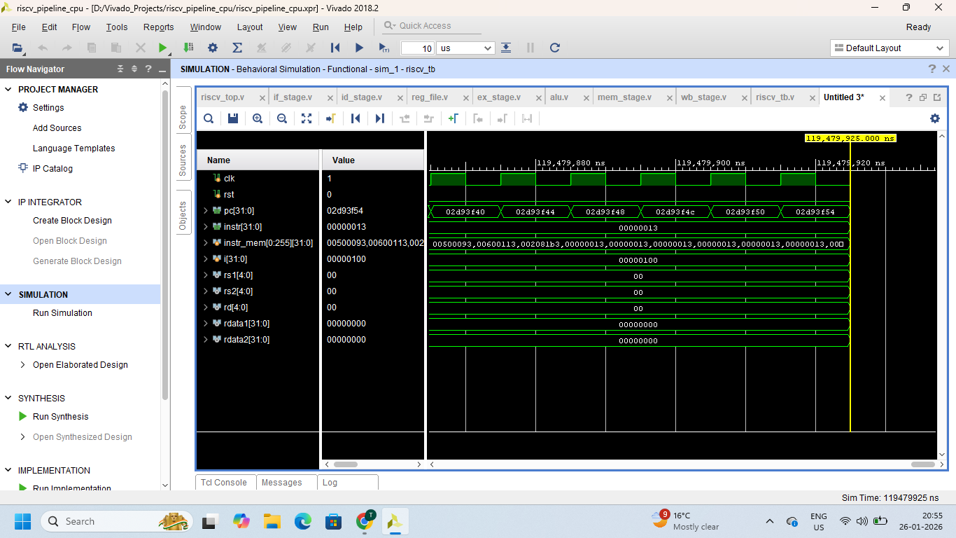
7.2 5-Stage Pipeline Simulation
In the 5-stage pipeline configuration, multiple instructions are processed concurrently across different stages. The waveform clearly shows instruction overlap across IF, ID, EX, MEM, and WB stages, demonstrating improved throughput.

8. Pipeline Hazard Analysis
8.1 Data Hazards
Data hazards occur when an instruction depends on the result of a previous instruction. In this design, explicit forwarding or stall logic is not implemented. Instead, NOP instructions are used to avoid incorrect execution.
8.2 Control Hazards
Control hazards arise from branch and jump instructions. Since the test program does not include branch instructions, control hazards were not observed.
8.3 Structural Hazards
Structural hazards occur due to resource conflicts. The modular design of the processor avoids such conflicts.

9. Comparison Between 3-Stage and 5-Stage Pipelines
Feature | 3-Stage Pipeline | 5-Stage Pipeline
Pipeline Depth | Low | High
Instruction Overlap | Limited | High
Throughput | Lower | Higher
Control Complexity | Simple | Complex
Hardware Cost | Low | Higher

10. Conclusion
This project successfully demonstrates the design and simulation of a configurable RISC-V pipeline processor. Both 3-stage and 5-stage pipeline architectures were implemented and verified using Vivado 2018.2. Simulation results confirm correct instruction execution and pipeline behavior. The 5-stage pipeline achieves higher throughput due to increased parallelism, while the 3-stage pipeline offers simpler control logic. The project effectively highlights the trade-off between performance and design complexity.

